ŠKODA POPULAR ‘MONTE CARLO’ (1937)

Between 1935 and 1938, two racing specials followed by 70 special limited edition vehicles were manufactured in honour of the success achieved by the Czechoslovak drivers at the renowned winter Monte Carlo Rally 1936.

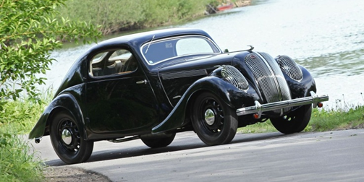
Vehicle specifications:

Engine:  Displacement:  Output:  Carburettor:  Gearbox:  Max. speed:  Length x width x height:  Wheelbase:  Weight: | four-spoke in-line four-cylinder with SV valve train, located longitudinally behind the front axle, liquid-cooled  1,386 cc  31 k/ 22 kW at 3,500 rpm  Solex carburettor  3+R  110-125 km/h  4,200 x 1,500 x 1,370 mm  2,570 mm  960 kg

This piece has been in the possession of the ŠKODA Museum since 1968.
The complete vehicle was purchased at that time, but an extensive renovation was necessary.
This only began at the turn of the millennium and finished in 2002.
Since then the car has been used for various presentations and vintage car events.

.

